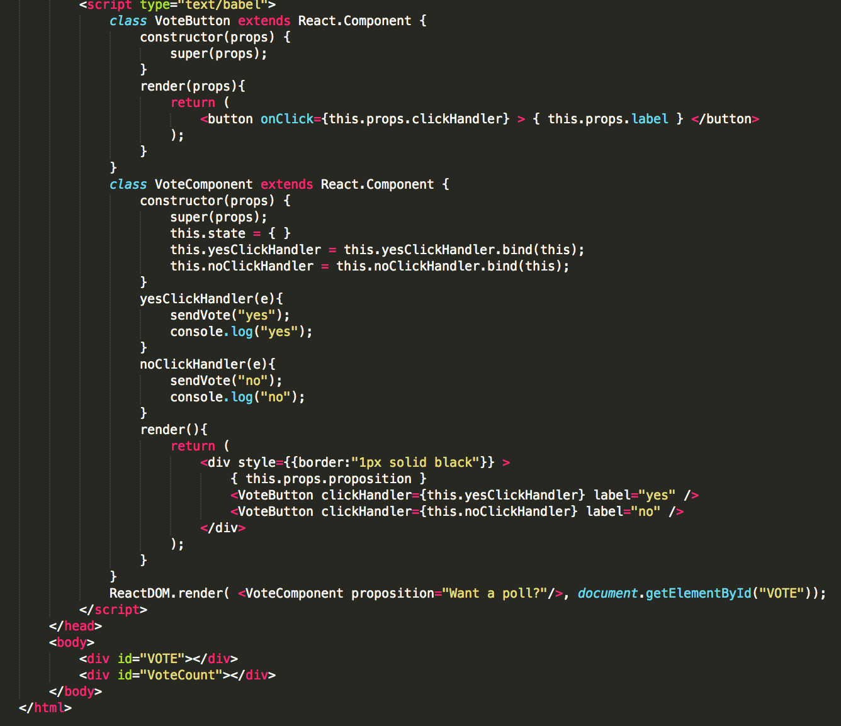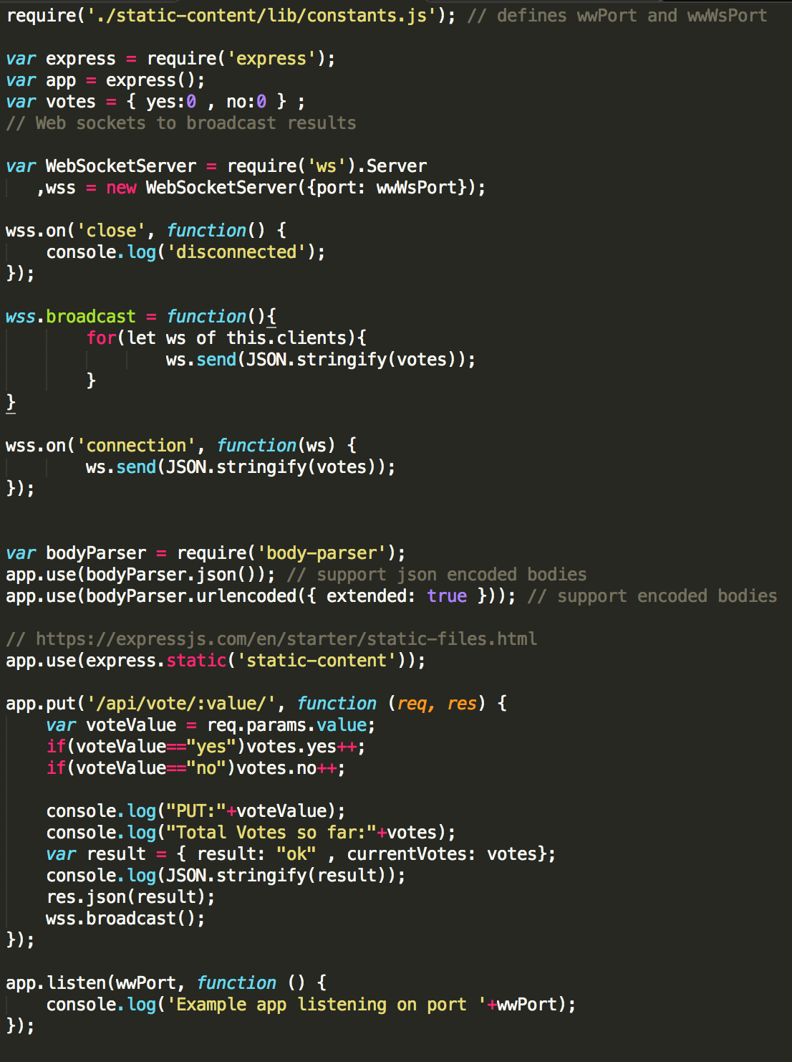

**(HTTP Request)**

POST /~arnold/app/login.php HTTP/1.1

Host: www.cslinux.utm.utoronto.ca

Accept-language: en-us

Cookie: hello=world; PHPSESSID=32r2423432432

Content-type: text/html

user=arnold&password=spiderman

**(HTTP Response)**

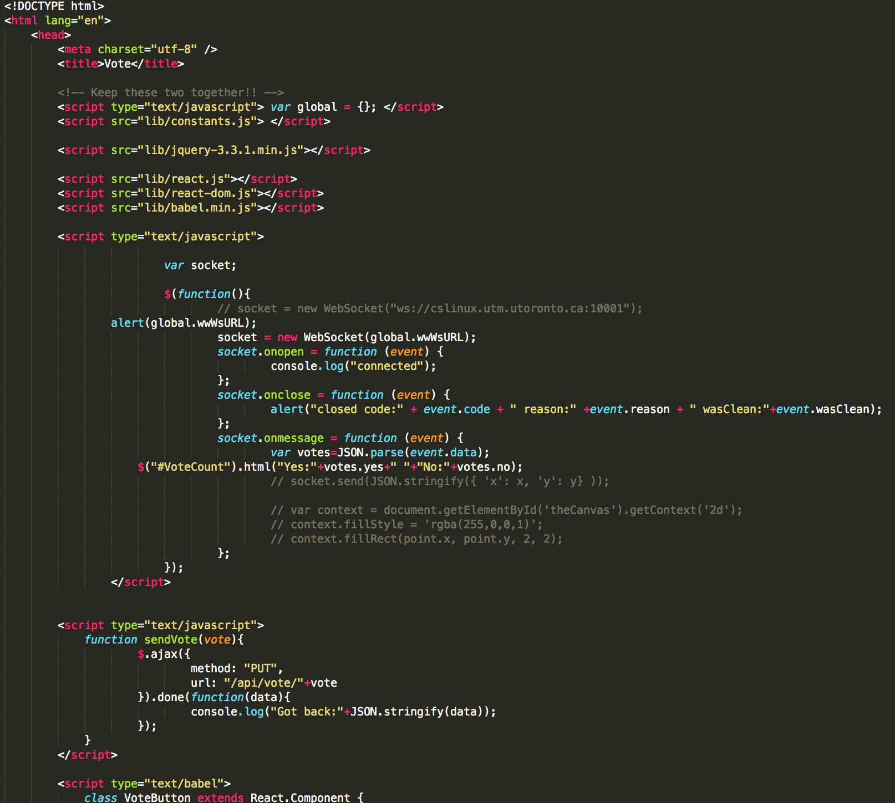

HTTP/1.1 200 OK

Date: Mon, 16 Apr 2018 20:69 GMT

Server: apache

Connection: Closed

Set-Cookie:

name=value

[;EXPIRES=dateValue]

[;DOMAIN=domainName]

[;PATH=pathName]

[;SECURE]

Content-Type: text/html; charset: utf-8

A GET request along with the associated responce. For a GET request, the body is empty.

**GET /~arnold/index.html HTTP/1.1**

**Host: localhost**

**HTTP/1.1 200 OK**

**Date: Thu, 23 Jan 2014 04:32:32 GMT**

**Server: Apache/2.4.6 (Ubuntu)**

**Last-Modified: Mon, 13 Jan 2014 14:32:04 GMT**

**ETag: "2c-4efdaf08b1a5a"**

**Accept-Ranges: bytes**

**Content-Length: 44**

**Content-Type: text/html**

**<html>**

**<body>**

**Got here!**

**</body>**

**</html>**

**GET /~arnold/missing.html HTTP/1.1**

**Host: localhost**

**HTTP/1.1 404 Not Found**

**Date: Thu, 23 Jan 2014 04:34:55 GMT**

**Server: Apache/2.4.6 (Ubuntu)**

**Content-Length: 292**

**Content-Type: text/html; charset=iso-8859-1**

**<!DOCTYPE HTML PUBLIC "-//IETF//DTD HTML 2.0//EN">**

**<html><head>**

**<title>404 Not Found</title>**

**</head><body>**

**<h1>Not Found</h1>**

**<p>The requested URL /~arnold/missing.html was not found on this server.</p>**

**<hr>**

**<address>Apache/2.4.6 (Ubuntu) Server at localhost Port 80</address>**

**</body></html>**

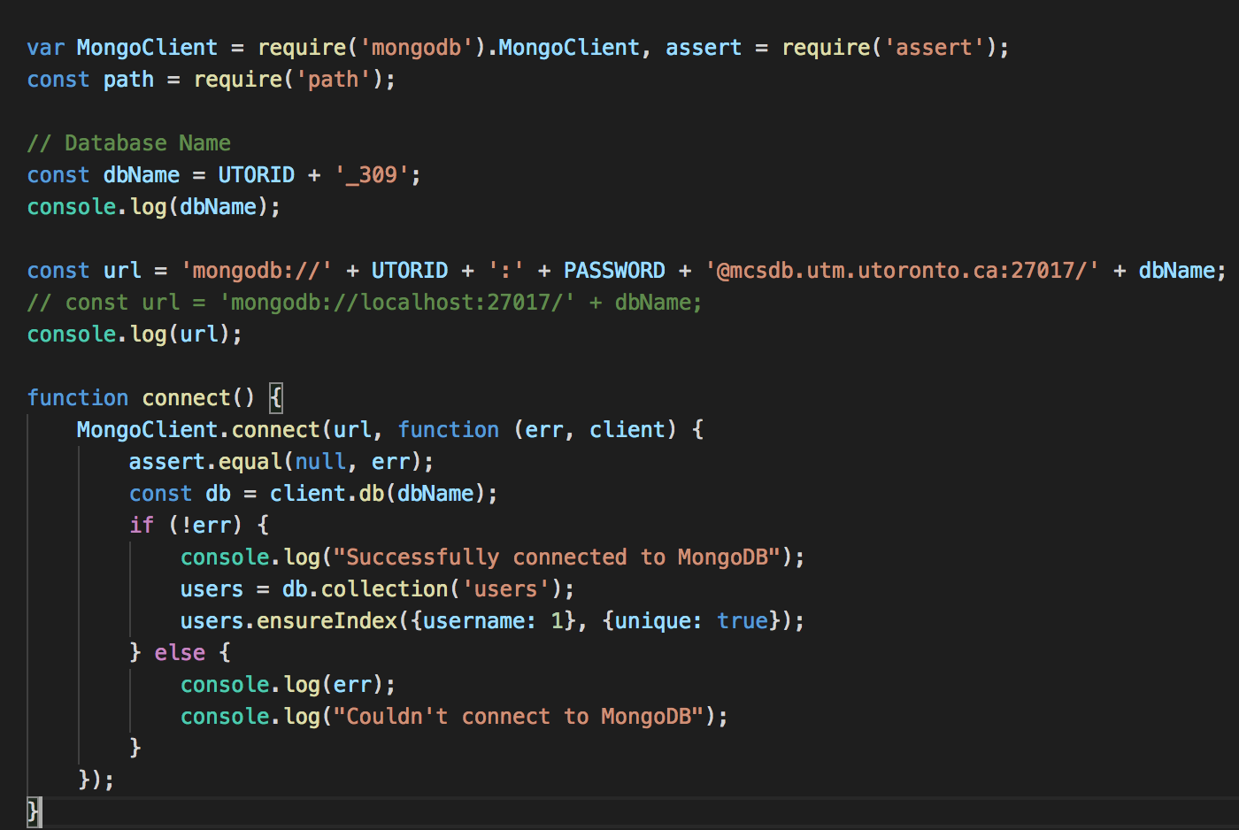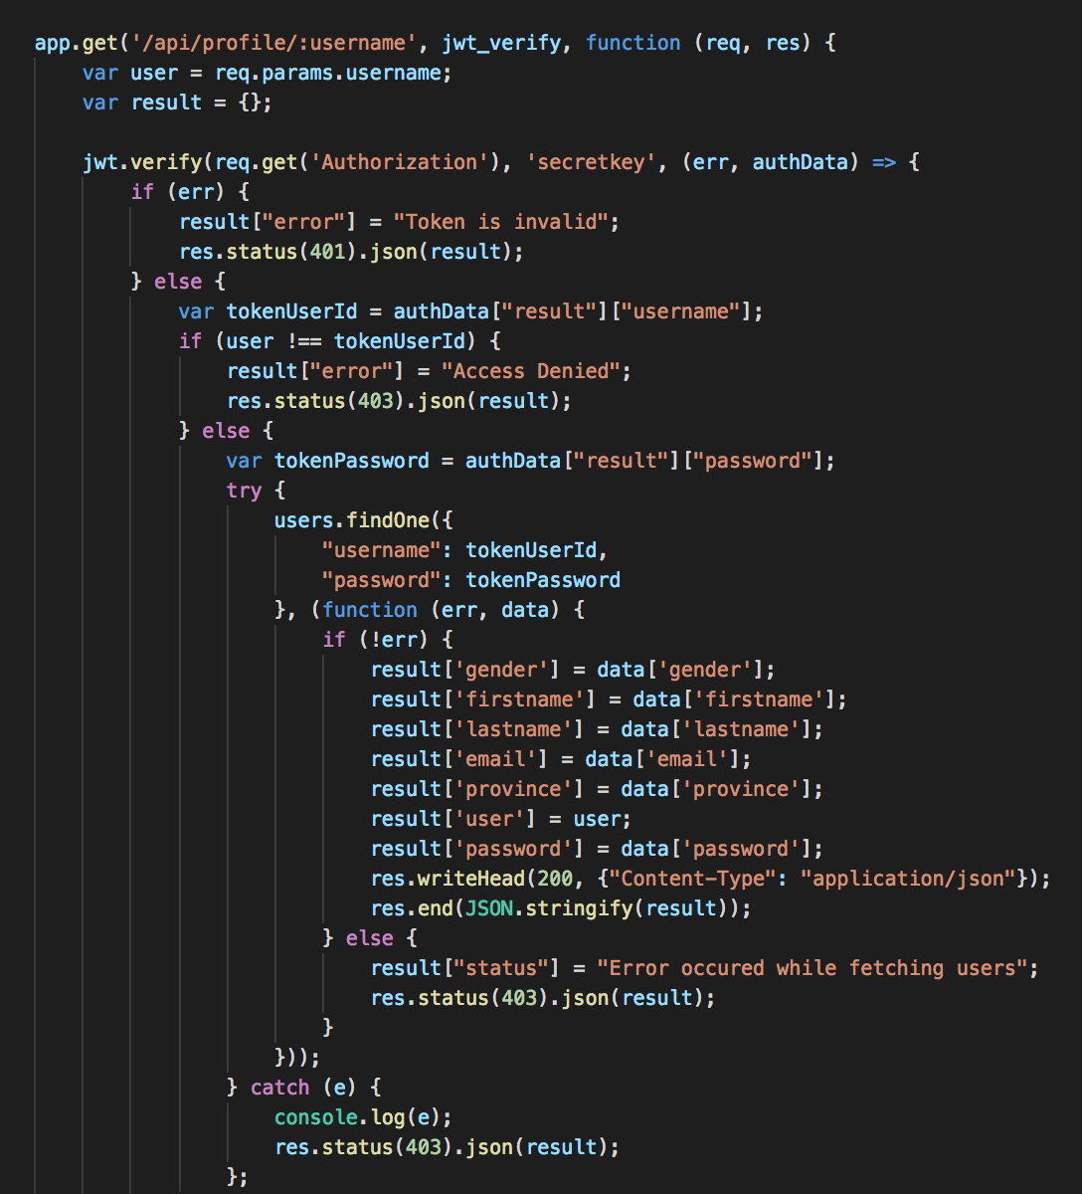

status codes look like   
1xx=information   
2xx=success   
3xx=redirect   
4xx=client error   
5xx=server error

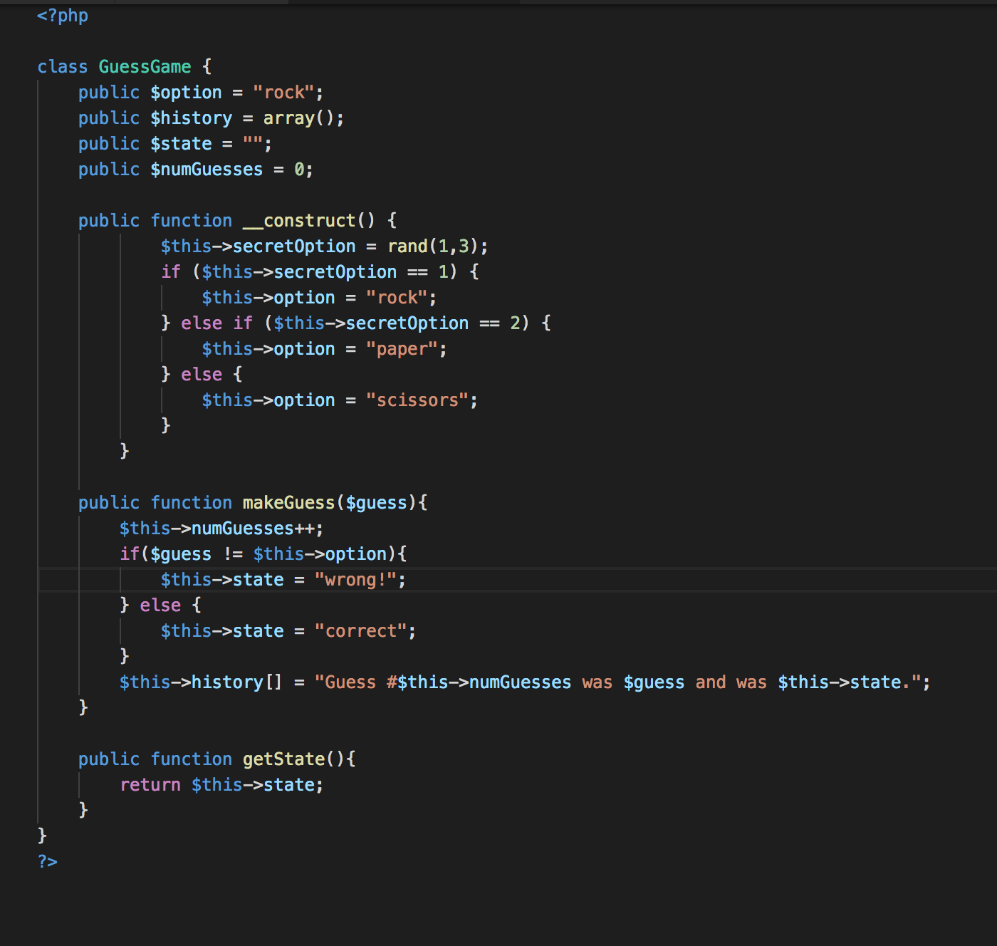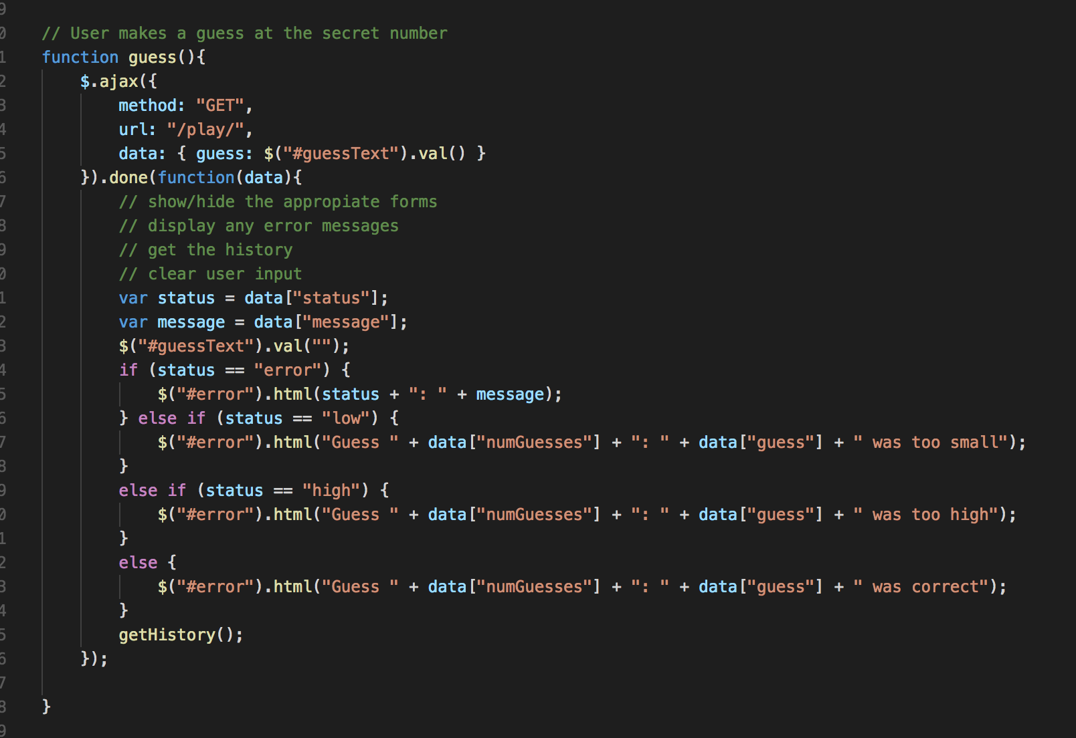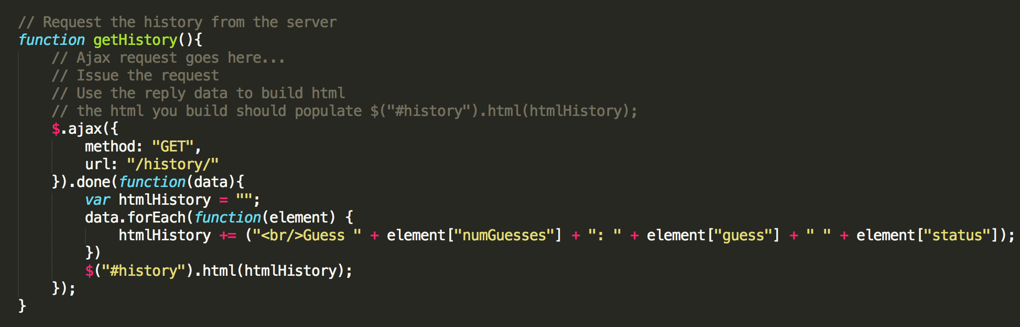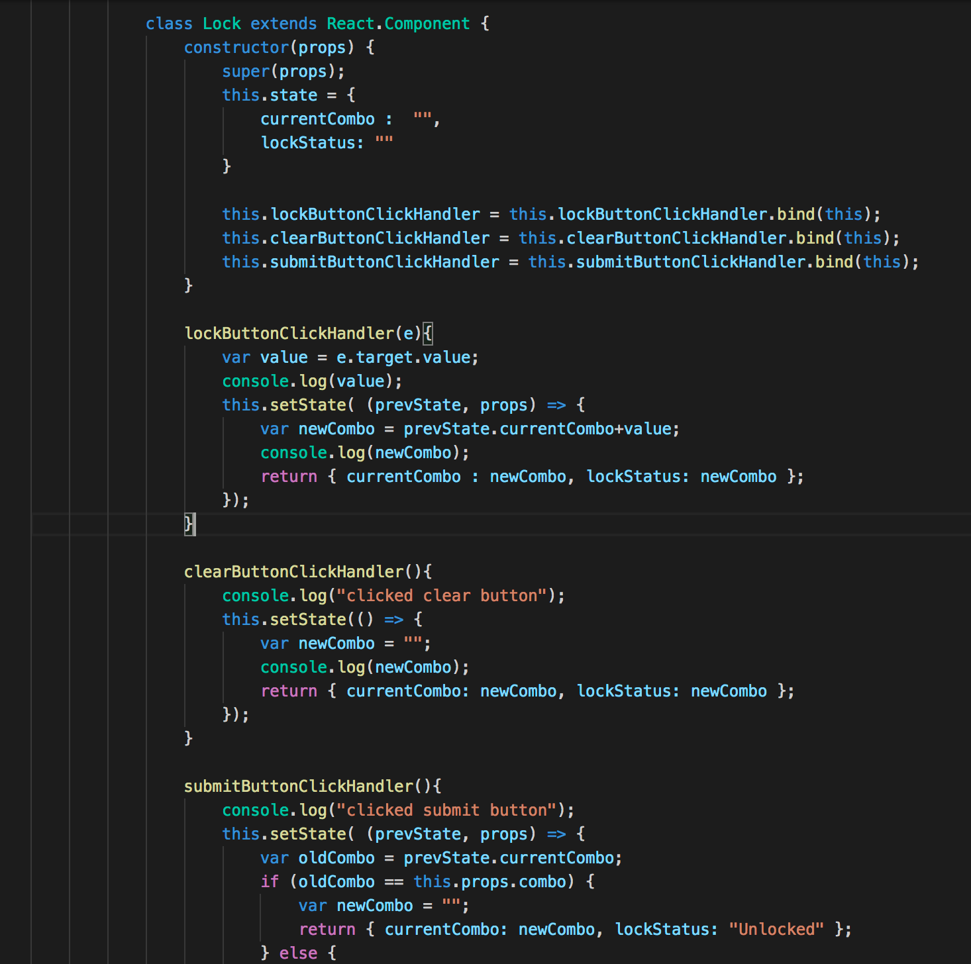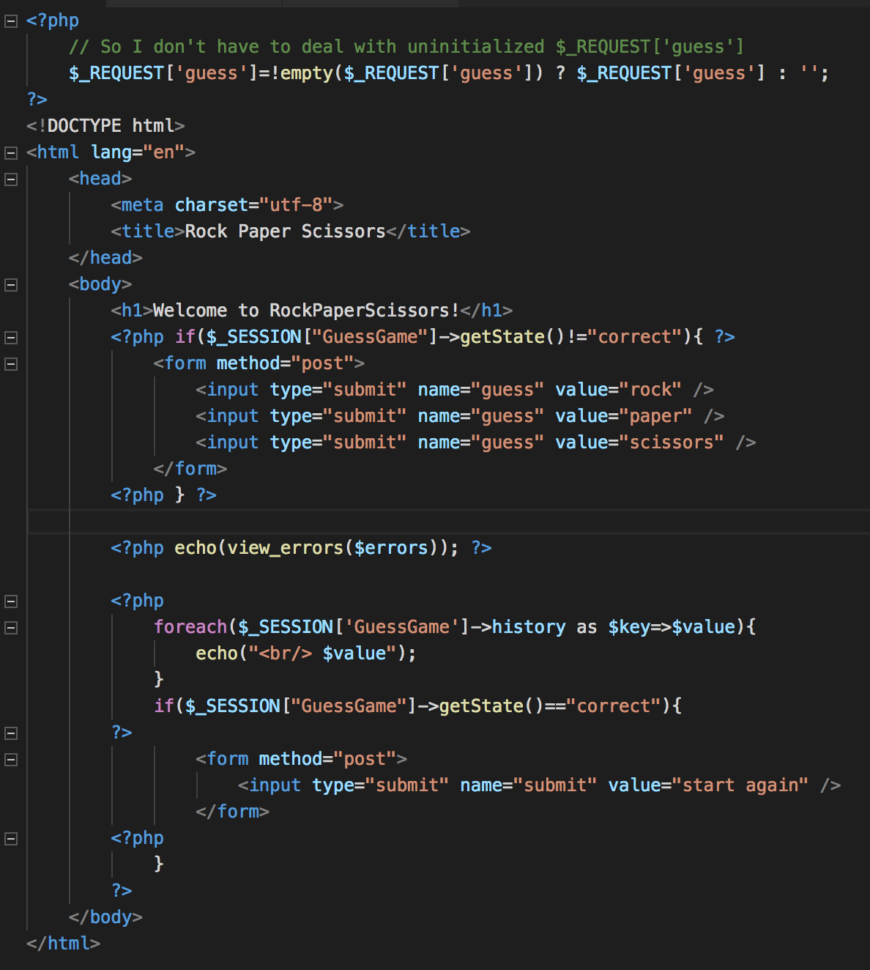

CGI script handles one request then terminates:

HTTP_HOST=www.cs.toronto.edu

DOCUMENT_ROOT=/cs/htdocs

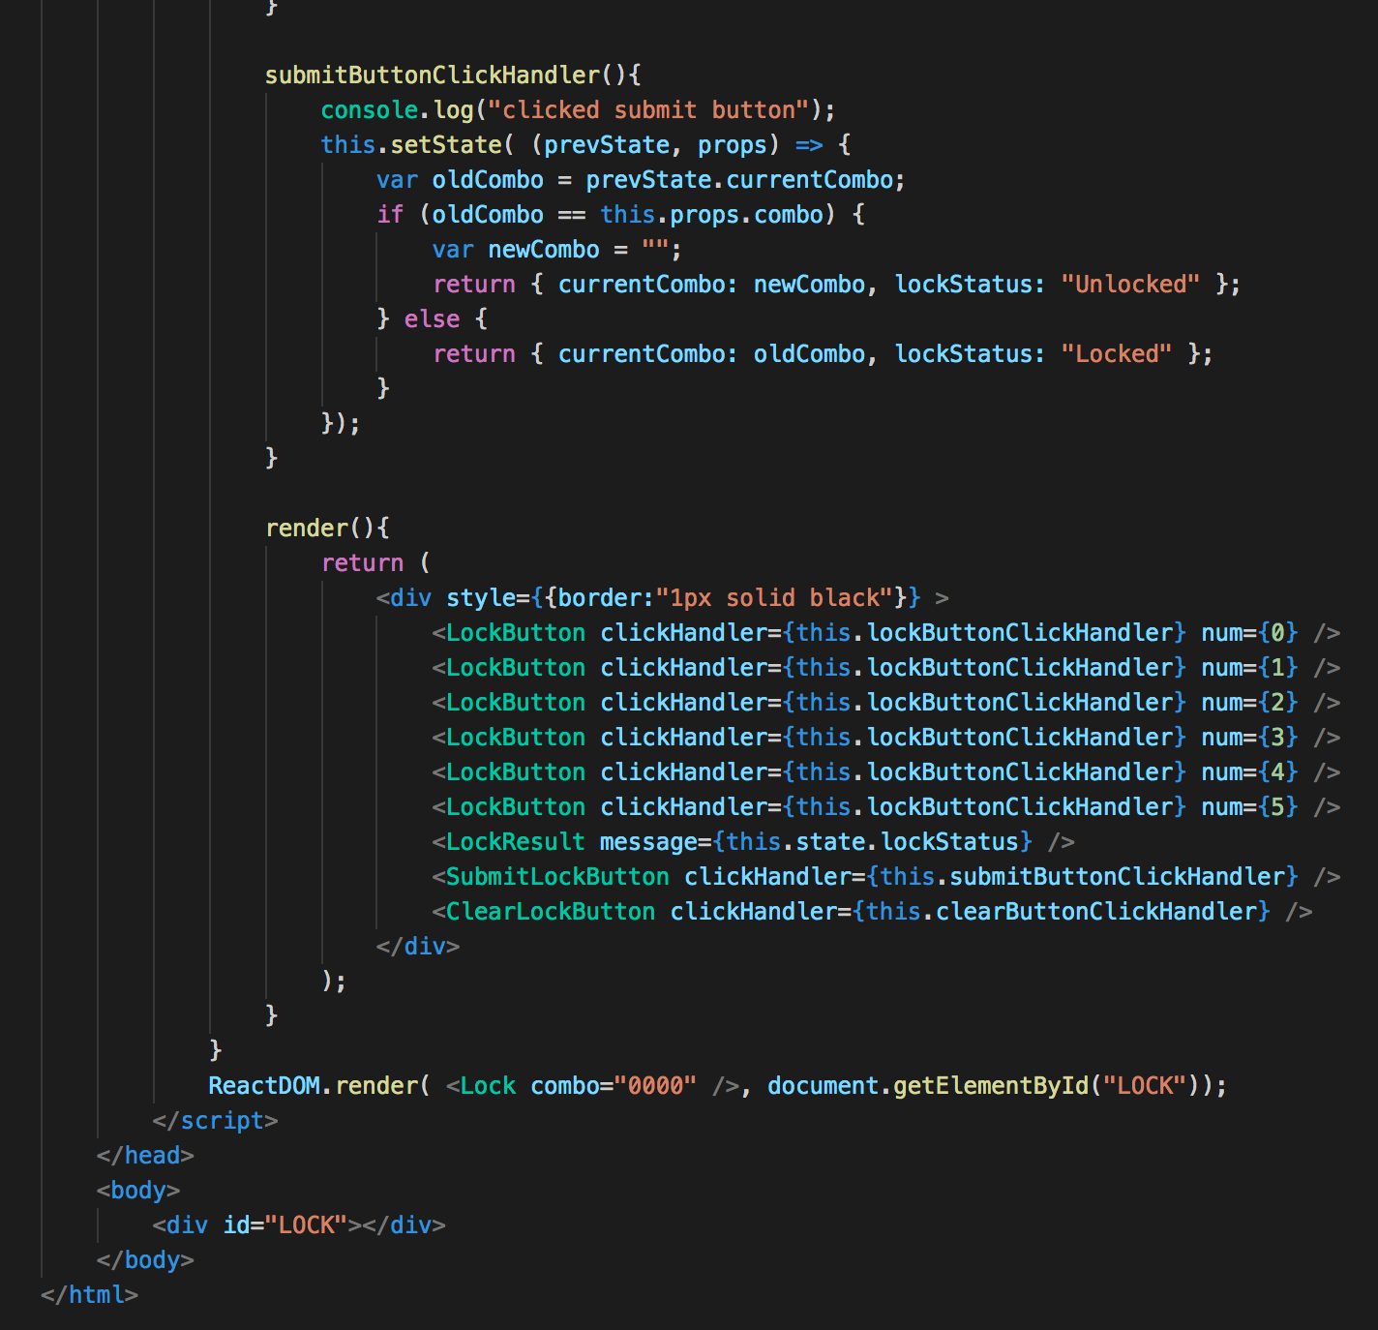

SERVER_ADDR=128.100.3.30

SCRIPT_URL=/~arnold/cgi-bin/environment.cgi

GATEWAY_INTERFACE=CGI/1.1

REQUEST_URI=/~arnold/cgi-bin/environment.cgi?answer=Who%27s+there

PATH=/usr/local/bin:/usr/bin:/bin

HTTP_X_FORWARDED_FOR=172.28.179.33

SERVER_PROTOCOL=HTTP/1.1

REMOTE_ADDR=137.132.3.8

HTTP_COOKIE=

HTTP_ACCEPT_LANGUAGE=en-US,en;q=0.5

SERVER_SIGNATURE=

Apache/2.2.22 (Ubuntu) Server at www.cs.toronto.edu Port 80

SERVER_PORT=80

HTTP_USER_AGENT=Mozilla/5.0 (X11; Ubuntu; Linux x86_64; rv:26.0) Gecko/20100101 Firefox/26.0

REMOTE_PORT=32393

QUERY_STRING=answer=Who%27s+there

SERVER_SOFTWARE=Apache/2.2.22 (Ubuntu)

SCRIPT_FILENAME=/cs/htuser/arnold/public_html/cgi-bin/environment.cgi

SCRIPT_URI=http://www.cs.toronto.edu/~arnold/cgi-bin/environment.cgi

HTTP_ACCEPT=text/html,application/xhtml+xml,application/xml;

q=0.9,*/*;q=0.8

REQUEST_METHOD=GET

HTTP_CONNECTION=keep-alive

HTTP_ACCEPT_ENCODING=gzip, deflate

SERVER_ADMIN=www@cs.toronto.edu

HTTP_REFERER=http://www.cs.toronto.edu/~arnold/cp3101b/lectures/

htmlIntro/forms.html

SERVER_NAME=www.cs.toronto.edu

SCRIPT_NAME=/~arnold/cgi-bin/environment.cgi

STDIN

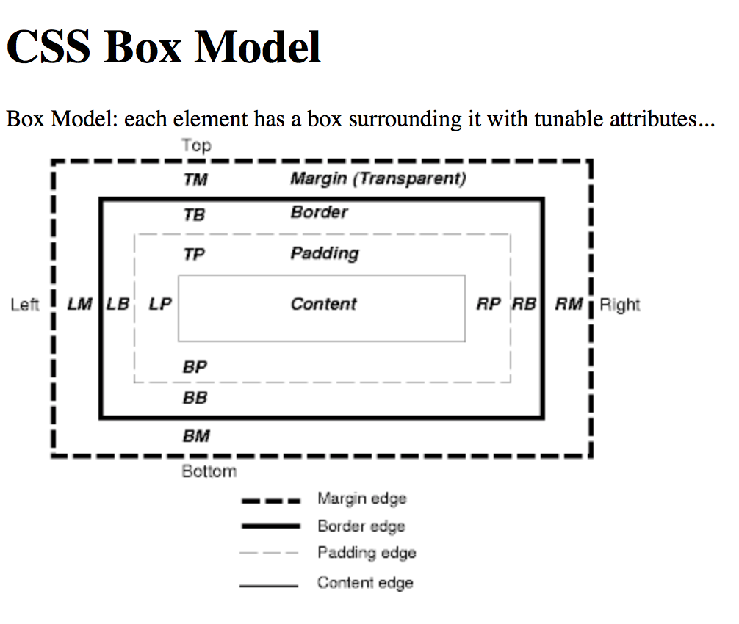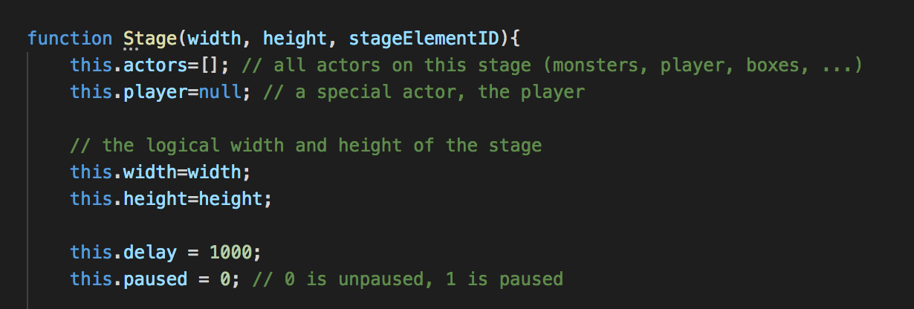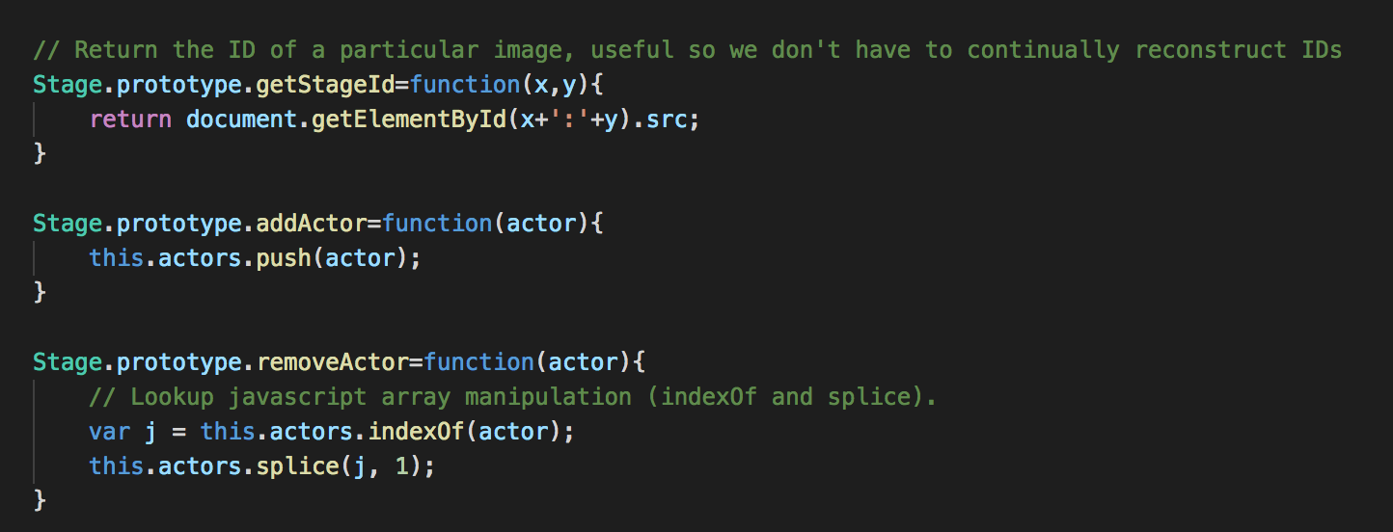

**$(document).ready(function() {**

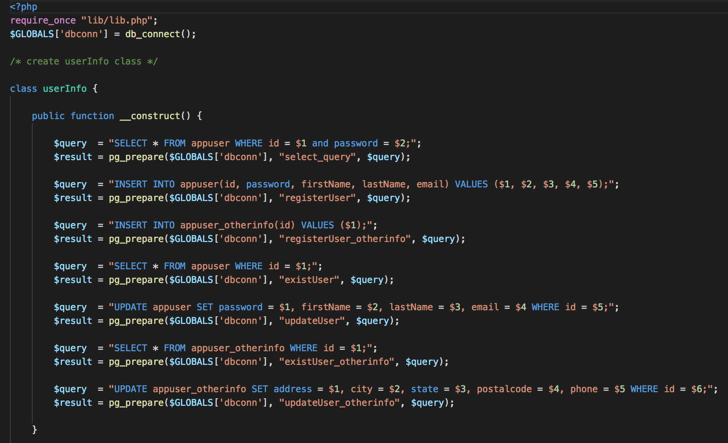

**Without arrow functions:**

Var self = this;

self.speed = 0;

setInterval( function() {

self.speed …..}

With arrow functions:

This.speed = 0

SetInterval( () => {this.speed++;}….

